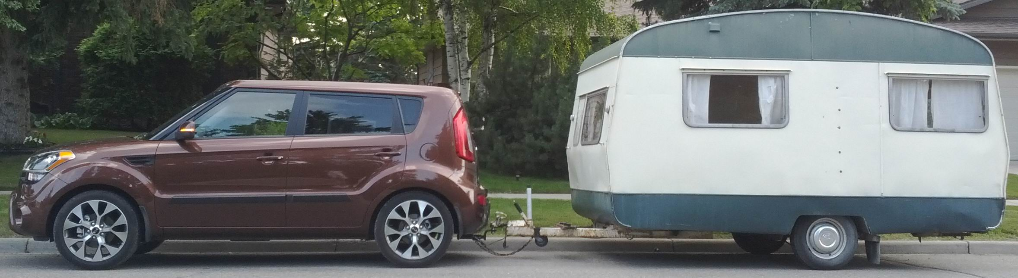
1965 Sprite Alpine
Renovations Underway!
See details at http://sprite.allansplace.ca/

