1974 Alpine Sprite
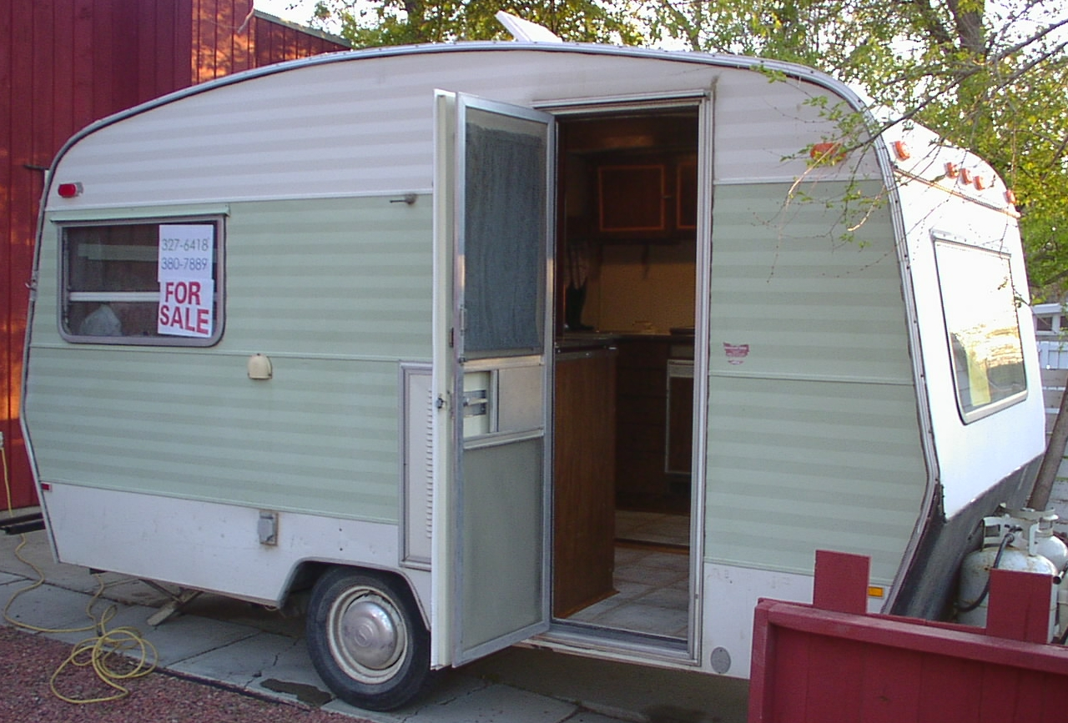
14’ camper trailer
- very clean!
- everything works! – no surprises
- lightweight, made in Britain
- no leaks
- sleeps 4
- 2-way fridge serviced by Skyline RV in May 2002
- 3-burner stove
- strong furnace!
- new hand / electric water pump*
- new Canadian Tire battery*
- new linoleum flooring and edging*
- new smoke detector*
- new fire extinguisher with certificates*
- new drinking water tank*
- new full-length mirror*
- new outside lights*
- bathroom with new chemical toilet* – never used
- hydraulic brakes
- awning
* new parts in May 2002
going to school – need the money!
$2600

Allan – 380-7889
Annette – 327-6418

